A Project report on

A Study on Fundamentals of C Programming
Tic-Tac-Toe Game

Submitted By
Vedant Gondhali
(Seat no. 11470011)
Under the Guidance of
Prof. Amiruddin Shaikh

Submitted in partial fulfilment of the requirement for the degree of
B.Sc. in Business and AI


Department of Business AI
INSTITUTE OF SCIENCE
(Academic Year 2025-26)


Industry project Sem-I FY B.sc (Business AI)

Dr. Homi Bhabha State University
Institute of Science College
15, Madam Cama Road, Mumbai-400 032
…………………………………………………………………………………… ……………………………………………………………………………………
Tel. No. (022) 48904545 Email:hbsu.support@digivarsity.com

DEPARTMENT OF BUSINESS AI CERTIFICATE
This is to certify that Mr. Vedant Gondhali having Exam Seat No./Roll No. 2025103082 B.Sc.-Business AI (Semester I) has completed the Practical work in the subject Industry Project during the academic Year 2025-26 under the guidance of Prof. Amiruddin Shaikh being the partial Requirement for the fulfilment of the curriculum of Degree of Bachelor of Business & AI, Institute of Science, Dr. Homi Bhabha State University.
.
Professor In-Charge Date: - …………………….

Coordinator College-Seal

Disclaimer
I certify that
- The work contained in this report is original and has been done by
myself under the general supervision of my supervisors.

- The work has not been submitted to any other Institute for a degree or diploma.

- I have followed the Institute’s norms and guidelines and abide by the regulations as given in the Ethical Code of Conduct of the Institute.

- Whenever I have used materials (data, theory and text) from other sources, I have given due credit to them by citing them in the text of the thesis and giving their details in the reference section.

- The report document has been thoroughly checked to exclude plagiarism.

Signature of the student
Seat No. 11470011
Acknowledgement

I would like to express my sincere gratitude to my thesis advisor, Prof. Amiruddin Shaikh and Sir Rohit Pawar for their valuable guidance, continuous support, and constructive feedback throughout the research process. Her insights and encouragement played an important role in shaping this work and improving its overall quality.
I am thankful to the faculty members of the B.Sc. in Business AI program for providing a strong academic foundation and for their constant support during my studies. Their teaching and guidance helped me develop the analytical and practical understanding required for this project.
I also wish to acknowledge my peers and classmates for their cooperation, discussions, and motivation, which made the learning experience more meaningful. I am equally grateful to my family for their encouragement and support throughout the completion of this report.
Lastly, I extend my sincere thanks to the entrepreneurs and business professionals who shared their experiences and insights. Their practical perspectives added real-world relevance to this research and contributed significantly to its successful completion.

-Index-
- Introduction  1.1 Programming domain  1.2 What is Tic-Tac-Toe Game  1.3Objectives | 1  1  1  1
- Review of Literature | 3
- Game Synopsis  3.1 Basic Game format  3.2 Question Bank | 8  9  10
- Flowchart  4.1 Level Selection  4.2 Levels  4.3 Randomizer  4.4 Tic Tac Toe Game  4.5 Question Bank | 12  12  14  19  20  22
- Pseudocode  5.1 Header File  5.2 Level Selection  5.3 Multiple Choice Question  5.4 Randomizer  5.5 Tic Tac Toe Game | 23  24  25  27  30  31
- Program Modules  6.1 Tic Tac Toe Game  6.2 MCQ Question bank  6.3 Randomizer  6.4 Level selection with Level condition | 38  39  53  58  60
- Game Testing  7.1 Level Selection  7.2Player precedence  7.3 Mcq system  7.4 Matrix display  7.5 Player input  - Matrix update after input  7.7 Winning condition  7.8 Draw | 78  80  82  83  86  87  92  93  95
- Conclusion and Learnings  8.1 Conclusion  8.2 Learning | 96  97  98
- References | 101

-Introduction-

1.1 Programming domain
C is a general-purpose programming language developed by Dennis Ritchie at Bell Labs in the early 1970s its was made primarily to incorporate UNIX operating system. It has direct access to low level abstraction and hardware control. C has since become foundational in the development of operating systems, compilers, embedded systems, and performance critical applications.
1.2 What is Tic-Tac-Toe Game
A common paper pen classic game “Tic Tac Toe” also known as “X & O” is household name for known for its simplicity and ease to understand game rules. Known by people of all ages played at any point of time whether they are bored during a lecture or just want to find a way to compete in a mind strategy game. Despite its simple appearance, the game offers interesting strategy: when both players play optimally, the result is almost always a draw. It has its reference from the game “Noughts and crosses” reflecting the marks used in the game: O’s (“noughts”) and X’s (“crosses”). “Tic-tac-toe” appears to derive from older expressions like “tick-tack”, “tit-tat” or “tick-tack-toe”, which were used for other games or rhythms, and later adapted for this one.
Having outlined what the game of Tic-Tac-Toe is and why it serves as a useful learning project, we now turn to the key challenges encountered when translating that game concept into code using the C programming language. When writing a program in the C language, you often face issues like using a box(variable)without first putting anything inside it(an un-initialized variable),trying to mark a spot outside a 3×3 game board(going outside array bounds),confusing“= means set “with“==means compare”(an assignment vs comparison mix-up),or giving the computer more sweets(data)than the box can hold(buffer overflow). These problems can make your program behave incorrectly or crash, so being aware of them helps you write better C code from the start.
How can we design and implement a C-based, two-player Tic-Tac-Toe game that incorporates an additional gameplay element while maintaining simple and low-level executable logic?
1.3 Objectives
- Create a c program to run the tic tac toe game with player inputs.
- Add a new aspect to the game.
- Make it a 2-player game.
- Define a simple and easy to understand game logic to make the program execution be possible and low-level system.
To handle invalid user inputs and make the game runs smoothly without crashing
This shall be achieved by creating a basic pseudocode defining the functions of the code as well as a through explanation of the code. The creative aspect of challenge that shall be added to the game is that players shall be able to answer the questions which will help them able to play their turn. Since c is a low-level language, the code shall be able to run on all low-level systems that are able to run the c idle.

-Review of Literature-

“Tic Tac Toe Game in C “ By: GeeksforGeeks
The article “Tic-Tac-Toe Game in C” from GeeksforGeeks provides a complete and well-structured example of building the Tic-Tac-Toe game using the C programming language. It begins by introducing the basic rules of the game, explaining the structure of the 3×3 grid, and describing the roles of the players. The article then presents a full program implementation, including functions for setting up and displaying the board, taking player input, checking for winning conditions, and determining draw scenarios. It also introduces the logic behind evaluating game moves, making decisions, and handling game flow in a step-by-step manner.
A major contribution of this source is its demonstration of modular programming in C. Each key task in the game such as checking rows, columns, and diagonals is implemented through separate functions, showing how clean code structure improves readability and maintainability. This structured approach helps learners clearly understand how different parts of the program interact to produce a working game. The reference additionally includes an explanation of using the minimax algorithm to simulate an intelligent computer opponent, highlighting an important concept in game theory and artificial intelligence for strategic decision-making in games.
This literature is particularly relevant to the current project because it offers a strong foundation for implementing Tic-Tac-Toe logic in C. The techniques shown for managing the board, validating player inputs, and detecting the game outcome can be directly applied. The project can also benefit from the structured approach demonstrated in the source, which emphasizes clear function use, logical flow control, and proper handling of game states. By studying this reference, the project builds upon established programming practices and enhances them while introducing additional elements like randomization and MCQ-based interaction to create a more interactive and enriched learning experience.
“Tic Tac Toe in C Programming Tutorial for Beginners Programming Project (YouTube)”By: Code Cookie
The YouTube tutorial “Tic Tac Toe in C Programming Tutorial for Beginners” demonstrates a foundational approach to building a console-based Tic-Tac-Toe game using the C language. The video serves as a practical learning resource, guiding viewers through key programming concepts that support interactive game development. It introduces the use of a 3×3 array to represent the game board and explains board initialization, display formatting, and turn-based interaction between two players. The tutorial emphasizes core logic essential to game functionality, including user input handling, validating moves, alternating turns between Player X and Player O, and updating the board in real time.
A significant focus of the tutorial is on designing win-checking mechanisms. It explains how to verify winning combinations across rows, columns, and diagonals, as well as how to identify draw conditions when all positions are filled without a winner. Error handling, such as rejecting invalid input and prompting the user again, is also demonstrated, enhancing the program’s stability and user experience.
Furthermore, the instructor highlights the importance of modular programming by organizing the logic into functions like displaying the board, checking game outcomes, and processing player moves. This structured approach aligns with best coding practices and makes the program easier to understand, debug, and extend.
Overall, the tutorial contributes to the learning base for this project by offering a clear and applied example of implementing Tic-Tac-Toe in C. It reinforces fundamental programming concepts such as arrays, conditionals, loops, and functions, forming a foundation upon which this project expands—through the inclusion of additional gameplay features like randomization and a quiz component for enhanced interactivity.
“Quiz Game in C” By: GeeksforGeeks
The article “Quiz Game in Published on GeeksforGeeks explains the design and implementation of a simple quiz game using the C programming language. It demonstrates how C can be used to create an interactive multiple-choice question(MCQ) system where the user is presented with questions, selects an answer, and receives immediate feedback. The program uses basic C concepts such as arrays, structures, loops, conditionals, and randomization to create a functioning quiz environment. It begins with defining necessary header files and constants using #define, then declares a structure to store the question text, options, and the correct answer. The article proceeds to describe functions that display questions, verify user answers, and calculate scores.
The code in the GeeksforGeeks tutorial employs the rand() and srand (time(NULL)) functions to generate random question indices, ensuring that questions appear in a non-sequential order. This feature enhances user engagement by introducing unpredictability into the game. The quiz logic includes components for displaying questions, taking user input, validating answers, and maintaining a score tally. Each correct answer contributes to the user’s score, and at the end of the quiz, the program displays the total points scored by the participant. The author provides a well-commented example code and explains each section in detail, making it accessible for beginners in C programming.
The relevance of this article to the present project lies in its structural and logical similarity. The current MCQ-based program also uses arrays to store questions, options, and correct answers, while employing the rand() function for random selection—reflecting the methodology demonstrated in the GeeksforGeeks tutorial. Furthermore, the concept of presenting questions sequentially and validating user responses is directly aligned with the techniques discussed in the article. However, the current implementation introduces additional features such as a “gate-until-correct” mechanism, where the user must answer correctly before proceeding, and improved input handling using the getchar() function for character-based validation. These enhancements make the program more interactive and robust than the base model provided by GeeksforGeeks.
While the GeeksforGeeks article serves as a strong foundational reference for quiz-based programming in C, it has certain limitations. The original code is restricted to a small, fixed number of questions and primarily focuses on score tracking rather than continuous gameplay. It also does not account for invalid input handling or repeated questions. In contrast, the current program expands on these ideas by allowing a larger number of MCQs, better error checking, and a more flexible gameplay experience. Thus, the project builds upon and extends the existing literature by refining the logic, structure, and educational engagement of the original quiz concept.
“Multiple choice menu program in C using the switch statement and scanf () function [duplicate]” by: Stack Overflow
The Stack Overflow discussion titled “Multiple Choice Menu Program in C using the switch statement and scanf() function” (2015) explains how to create a basic menu-driven program in the C language using the switch statement and user input through scanf(). In this program, the user can choose different options from a menu, and depending on the input, the program performs specific actions. The post highlights a common problem faced by many beginners in C—when using scanf("%c", &option), the program sometimes skips input or does not read the correct character. This happens because the newline character('\n') from the previous input remains in the input buffer.
The solutions provided in the discussion explain that this issue can be fixed by clearing the input buffer or by using functions like fgets()instead of scanf() for safer input handling. The experts also suggest better ways to handle user choices in loop structures, using while or do-while loops along with the switch statement. This method ensures that the menu keeps repeating until the user decides to exit. The thread therefore helps readers understand how to design an efficient and error-free menu system in C.
This reference is useful for my MCQ quiz program because it explains how to properly handle user input and prevent unwanted errors when taking answers from the keyboard. In my code, asgetchar() and loops— to remove unwanted newline characters and make sure that user input is read correctly. Like the Stack Overflow example, my program also depends on a clear and interactive menu-style flow where the user is repeatedly asked questions until the correct answer is given. This makes the learning process smoother and prevents the program from crashing or skipping inputs.
Overall, the Stack Overflow example is an important reference for understanding the logic behind menu-driven programs and user-input management in C. It provides practical insight into real programming issues that learners face and helps improve input handling in interactive programs like MCQ quizzes.

“ Quiz Game | C Programming Example ” by: portfolio course
The video demonstrates how to build a simple multiple-choice quiz game in C. It explains how to use structures (struct) to store each question along with four options and the correct answer. The creator then shows how to place these structures into an array, allowing the program to loop through all questions.
The program displays each question, reads the user's answer using basic input methods like scanf(), checks whether it is correct, and updates the score. At the end of the quiz, the program prints the user’s total score and percentage. The video serves as an easy coding tutorial for beginners, helping them understand the use of structs, arrays, loops, conditionals, and user input in C programming.
“ Let's code a QUIZ GAME with C programming! “by: Bro Code
The video teaches viewers how to build a simple quiz game in C using 2D arrays to store questions, options, and correct answers. The creator explains how to organize quiz data in arrays and then use loops to display each question to the user. The program takes the user’s input, compares it with the correct answer, and keeps track of the score.
The video focuses on helping beginners understand how arrays, loops, conditionals, and user input work together in C. It shows how to print questions, read answers using scanf(), validate choices, and finally display the user’s total score. Overall, the tutorial demonstrates a basic but effective structure for building interactive console-based quiz games.
“ C++ create a random number generator “ By: Bro Code
The video “C Random Numbers” contributes to foundational learning in computer programming by demonstrating the use of random number generation within the C language. Literature on randomization in C consistently emphasizes the importance of therand() and srand() functions as core tools for producing pseudo-random values, and this video aligns with those established concepts .It highlights how rand() can generate numbers within a default range, whilesrand() is used to seed the random number generator, often with the system time, to ensure variability across program runs. Earlier studies and tutorials on C programming stress that randomization is essential in simulations, gaming applications, statistical sampling, and security-related algorithms. The video reinforces these themes by providing practical examples that visually demonstrate how random number logic is implemented in code.
Furthermore, educational resources frequently point out that pseudo-random number generators follow deterministic algorithms, and therefore seeding plays a crucial role in preventing repetition of patterns. This idea is reflected in the video’s explanation of why time(NULL) is commonly used as a seed value. The content supports existing literature by showing how learners can control the range of random outputs through modular arithmetic, a method widely discussed in academic and technical texts. Overall, the video serves as a supplementary instructional material that complements standard literature by offering a simplified, visual walkthrough of concepts that are otherwise introduced through textbooks and programming guide

-Game synopsis-

3.1 Basic Game format
The game tic tac toe is a simple game that is easy to understand and play. The twist added to the game for this project is the answering of basic MCQ related to C programming language this adds a learning curve to the simple game this game is executed in the console of the computer hence it is hassle free to incorporate in any system.
The basic game starts with the level selection and then defining the level according to which the game is going to be executed. Following are the levels and the difficulty increase: -
- Level1: answer 1 MCQ correctly to play your turn
- Level2: answer 2 MCQ correctly to play your turn
- Level3: answer 3 MCQ correctly to play your turn
- Level4: answer 4 MCQ correctly to play your turn
- Level5: answer 5 MCQ correctly to play your turn
After the level selection we get to play our turn.
This game is a 2-player game to allow us play with a friend hence is a multiplayer game. The limitation of this game is that this game is only be played on a local system. Always when we start the game player 1 is defined as “X” and player 2 is defined as “O”.
The game also has a update after every move and reprints the entire matrix in the console. For example, when a player gives the right answer as well as enters his move.
Also the questions required for the game are inspired from c programming fundamentals involving basic of c language

3.2 The questions:
1. Which operator assigns a value in C?
A. =
B. ==
C. :=
D. <-
Correct Answer: A. =
2. What is the result of 10 + 5 * 2 (int arithmetic)?
A. 30
B. 20
C. 25
D. 15
Correct Answer: B. 20
3. Which is a logical operator in C?
A. &
B. &&
C. |
D. /
Correct Answer: B. &&
4. What does == do?
A. Assignment
B. Equality check
C. Inequality check
D. Logical AND
Correct Answer: B. Equality check
5. What is 5 % 2?
A. 2
B. 2.5
C. 1
D. 0
Correct Answer: C. 1
6. Which operator dereferences a pointer?
A. &
B. *
C. ->
D. .
Correct Answer: B. *
7. Arrays in C start at index:
A. 1
B. 0
C. -1
D. Depends
Correct Answer: B. 0
8. Which has higher precedence in C?
A. *
B. =
C. &&
D. ++
Correct Answer: A. *
9. Which is the ternary operator?
A. :
B. if-else
C. ?:
D. ??
Correct Answer: C. ?:
10. Associativity of assignment operator = is:
A. Left to Right
B. Right to Left
C. Top to Bottom
D. No associativity
Correct Answer: B. Right to Left

-Flowchart-

Flowcharts helps us understand the working of the code and help us develop the pseudocode. We divide the flowchart into 4 categories to help us easy develop each segment of the pseudocode.
we divide the program into 5 major sections for the flow chart making to help us develop the code into individual parts ie.

- Level selection

This is the flowchart for level selection as we can see the program starts the function hence initiates the process of level selection and initiates the diction making of the code for selection levels. Player inputs are registered and the code ends. Further a node is attached to the code to connect it to the other code ie. Levels.

- Levels/MCQ
We further divide this part into 5 parts for each level where the flowchart changes according to each levels. As each different levels has a different game logic.
  - Level 1:
Here before playing your turn in the tic tac toe game 1 right MCQ shall be answered correctly.

The flow chart explains how the level works about answering the right answer further is the answer is correct the node is attached to the main tic tac toe program to give the green flag to enter the player position.

  - Level 2:
Here before playing your turn in the tic tac toe game 2 right MCQ shall be answered correctly.

The flow chart explains how the level works about answering the right answer further gives the chance to answer 2nd question to which when the answer is correct the node is attached to the main tic tac toe program to give the green flag to enter the player position.

  - Level 3:
Here before playing your turn in the tic tac toe game 3 right MCQ shall be answered correctly.

The flowchart shows The start of the code and a node is attached from level selection after which MCQ questions which is 3 questions and further after 3 questions a node is made attached to Tic Tac Toe Game.

  - Level 4:
Here before playing your turn in the tic tac toe game 4 right MCQ shall be answered correctly.
The flowchart shows The start of the code and a node is attached from level selection after which MCQ questions which is 4 questions and further after 4 questions a node is made attached to Tic Tac Toe Game.
  - Level 5:
Here before playing your turn in the tic tac toe game 5 right MCQ shall be answered correctly.
The flowchart shows the start of the code and a node is attached from level selection after which MCQ questions which is 5 questions and further after 5 questions a node is made attached to Tic Tac Toe Game.

- Randomizer
Randomizer helps us randomize the question asked helping us
series in which questions asked helping us by not making the repletion of question
asking pattern.

- Tic Tac Toe Game

This is the flowchart that represents the way the main game farmwork works it shows how the game is supposed to make decisions where the program starts there is a node that connects those program to the mcq module that helps us in understand that after answering the right mcq we receive a chance to paly our turn in the game.
in the flowchart when a person plays his turn the program checks if the position is occupied or not. If not the position is registered and move on to the next player where again the same condition is checked but also the 2nd player module communicates with node to get the right answer. Individual flowchart are show bellow chowing the difference in program from the above one:
Player 1 (“X”):

Player 2 (“O”):
These give us a brief idea of how the program works for each player where after player input for the mcq and checking the conditions the player is allowed to enter the position and the program checks if the positions is occupied . if occupied the player again gets a chance to play his turn. If not occupied the program ends or the other player gets a chance.
- Question bank
This module of the code stores the Questions asked in mcqs as well as the answers that are supposed to be printed as well as the mcqs options. This helps us hold a lot of questions in a small code snippet.
this chart explains the basics of the question bank and how it will be attached to the mcq levels module.

-Pseudocode-

Pseudocode is a easy to understand basic draft of the code. It helps us understand the basic functions we need to add in to the program so that we can easily convert it into an executable code. This creates a coding blueprint and acts as a Manuel to make the code.
It combines simple English phrases with some programming conventions, like if-else statements and loops, to create a readable, informal blueprint that is understandable to humans but cannot be compiled by a computer.
The pseudocode for the modules are: -
- Header file
we require important header files for running the program that are required for the basic operations that are
header <stdio.h>
header<stdlib.h>
header<ctype.h>
header<time.h>
We need these libraries for the following functions :-
header <stdio.h>
//for basic functions like print and scan
header<stdlib.h>
//for general functions eg. number generator[(rand)function]
header<ctype.h>
//for scanning input characters complexities
header<time.h>
//for importing time in the c program
stdio.h
The stdio.h header file in C provides a collection of functions for performing standard input and output operations, including console interaction and file handling.
Here are some of the most commonly used functions from stdio.h
- printf(): Used to print formatted output to the standard output (console).
- scanf(): Used to read formatted input from the standard input (keyboard).
- getchar(): Reads a single character from the standard input.
- putchar(): Writes a single character to the standard output.
- gets(): Reads a line of text from the standard input

stdlib.h
stdlib.h is a C standard library header file that provides general-purpose utility functions for tasks like memory allocation, process control, conversions, and random number generation.
Here are some of the most commonly used functions from stdlib.h:-
- Memory allocation: malloc(), calloc(), realloc() to allocate memory,
- Process control: exit() to terminate a program, abort() for abnormal termination, and system() to run commands in the operating system shell.
- String conversions: atoi() to convert a string to an integer, atol() for a long integer, atof() for a float, and strtod() for a double.
- Random numbers: rand() for generating pseudo-random numbers and srand() for seeding the generator.
- Other utilities: abs() for absolute value, div() for division, and getenv() to access environment variables.
ctype.h
ctype.h is a header file in C that contains functions for character handling, such as classification (e.g., checking if a character is a digit, uppercase, or lowercase) and conversion (e.g., converting a character to uppercase or lowercase)
time.h
time.h is a header file in the C programming languages that provides functions, types, and macros for working with time and date. It includes data types like time t for storing calendar time, clock t for processor time, and the struct tm structure for broken-down time components like hours, minutes, and seconds
- Level selection
When we start the game we need to select the game level. This is the part where the difficulty of the game is set up.
to develop this part of the game we need to understand the basic levels of the game.
To make a brief code mock up wee set the rules that will govern the level section of the game. For this we set up rules for the game that are:-
  - Level 1 : Answer one right mcq to proceed further with the chance to play the game
  - Level 2 : Answer two right mcq to proceed further with the chance to play the game
  - Level 3 : Answer three right mcq to proceed further with the chance to play the game
  - Level 4 : Answer four right mcq to proceed further with the chance to play the game
  - Level 5 : Answer five right mcq to proceed further with the chance to play the game

Start

Display “Select level (1-5): ”

Read player input = level input “%d”

If
input not a integer
Display “Please enter a valid number from the range”
Return to 1
Else
Set level (“%d”, level input)

If
level input == 1;
Set level = 1
else
level input == 2
Set level = 2
else
level input == 3
Set level = 3
else
level input == 4
Set level = 4
else
level input == 5
Set level = 5

Display “level selected : ‘Level input’ “

This was a base pseudocode describing the code in a very general manner with the help of if else ladder. First we see the program asks the user to input the choice of level futher the program with the help of if else ladder narrows down the program to player input.
If
level input == 1;
Set level = 1

This can be shown in the above pseudocode where we see if the level input equals to 1 the level selection will be 1. This shows how the shows the Level is selected

This program can be further be refined in the following way:
Begin

Display “Select level (1-5):”

Read Level input %d
If
input not a integer
Display “Please enter a valid number from the range”
Return to 1
else
Set level (“%d”, Level input)
Set level=1
else
set level = Level input

if level < 1
set level = 1
if level > 5
set level = 5

display “Level selected”
This refined form dose not use a if else ladder for level selection it uses range to define the selected level. This change reduces the clutter caused in the previous pseudocode. While the rest of the program remains the same.

- Multiple Choice Question
The MCQ framework in the program enhances the tic-tac-toe game by introducing an interactive quiz component across five difficulty levels. Each level requires the player to answer an increasing number of MCQs correctly before making a move, and the pseudocode is divided according to these five levels to clearly show how difficulty scales. The system randomly selects questions from a predefined question bank, presents four answer options, and validates the user's response using dedicated helper functions. Incorrect answers lead to repetition, ensuring the player meets the requirement for that level. Overall, this framework integrates learning with gameplay, making the experience more engaging, challenging, and structured across all five levels.
We divide this part of the pseudocode into 2 parts ie.
  - MCQ framework
  - Question libraries
We utilize the question library to print a random question with options to the mcq framework that it uses the library to print each question with its options and right answers to check the questions each one of them has a corelation to execute in properly.
- MCQ framework
This pseudocode is related towards the mcq framework of the game that shall be utilized add the difficulty in the levels. As per the rules in level selection we set mcqs. The questions shall use be randomized by a randomizer which will use the index value of the question to display the question. The displayed question is then utilized by the mcq part to print as well as check it whether its right of wrong to proceed to repeat the same function in co relation to the level selected by the player.
we divide the pseudocode into 5 parts according to the levels.
Basic MCQ framework:
Begin

Import the random no
Match the rand value to the question index
for player 1

Display question
Display options

Scan player input

If
Answer correct
Display “the answer is right. Proceed to play your turn.”

Else
Answer wrong
switch to player 2
Display question
Display options

Scan player input

If
Answer correct
Display “the answer is right. Proceed to play your turn.”

Else
Answer wrong
return player 1
End
As seen from the a above pseudocode we can see that a basic framework of the MCQ . We see that we first import the random no. This no is matched with the index value of the string. This question with its options is further printed in the console and scans for player input that shall be matched with the answer bank an then if the answer is right the player gets to play his or her turn, else the turn is given to player 2. The same steps are followed and the program returns to player 1.
This section also needs to add multiple questions according to the difficulty of the levels in game to do this we use a statement in the following manner for example we make a pseudocode for Level 2 :-
Begin
import the random no
match the rand no to question index

For player 1

Display the question
Display the options

Scan player input
If
Answer correct
Display the question
Display the options

Scan player input
If answer correct
Player 1 plays his turn

Else end player 2 gets chance
else
end player 2 gets chance

For player 2

Display the question
Display the options

Scan player input
If
Answer correct
Display the question
Display the options

Scan player input
If answer correct
Player 2 plays his turn

Else end player 1 gets chance
else
end
return 1

end

In this pseudocode snippet we can see the level 2 part of the mcq framework for level 2 where another question is asked if the answer is right another question is to be asked which shall be answered to play the turn.
- Randomizer
The randomizer randomises the question printing pattern so that the questions are randomized and there are no repetitive patterns in the questions asked. This adds an unexpected pattern leading to difficulty in the game pattern as players can’t, memorize the answers regarding to the pattern of questions asked.
Begin

Import time
number 1 = int

random no range 1 to 10

Display the no and number 1

Return0

end
This is a relatively a simple program to generate a random number it helps generate a random no by using the time as a seed to generate the random number between the range of 1 to 10.

- Tic Tac Toe game
This part is the most essential part of the program as we oversee the pseudocode for making the game of tic tac toe. We need to do the following things to make the tic tac toe game to work: -
  - Set the player assignment
  - Make the board that shall consist the board on which the X and O shall be printed
  - Make player input
  - Make winning conditions
    - Horizontal
    - Column
    - Diagonal
Begin

Player 1 = X
Player 2 = O

Player input
Player 1 = %d
Player 2 = %d
Print board
“ pos1 | pos2 |pos3
-------+--------+------
Pos4 | pos5 |pos6
-------+--------+------
Pos7 | pos8 |pos9 ”

Player input
for player 1
If
Player input = int range (1 to 9)
replace pos %d with “X”
Else
Print” please enter a valid position ”
for player 2
If
Player input = int range (1 to 9)
replace pos %d with “O”
Else
Print” please enter a valid position ”

Winning condition

Row check
switch
Case1” pos1 == pos2 == pos3” break
Case2” pos4 == pos5 == pos6” break
Case3” pos7 == pos8 == pos9” break

column check
switch
Case1” pos1 == pos4 == pos7” break
Case2” pos2 == pos5 == pos8” break
Case3” pos3 == pos6 == pos9” break
Diagonal check
switch
Case1” pos1 == pos5 == pos9” break
Case2” pos3 == pos5 == pos7” break

We first stat by assigning the “X” and “O” to the corresponding players in our case player 1 is “X”
Player 2 is “O”
As shown in the following snippet:
Player 1 = X
Player 2 = O

We then assign the player input for the input of matrix positioning. We assign the values as integers as the position in the matrix is in the form of numbers.
Player input
Player 1 = %d
Player 2 = %d

After assigning this we can continue the further pseudocode as the defining theses variables helps the program understand what values of input they shall be receiving.

We can now start with the main pseudocode where start with how the board looks on the console as well as the winning conditions of the race.
Print board
“ pos1 | pos2 |pos3
-------+--------+------
Pos4 | pos5 |pos6
-------+--------+------
Pos7 | pos8 |pos9 ”

This shows how the board will be printed in the game which is a three by three matrix with the indexing starting from left to right. This same indexing shall be used input the “X” and “O” positioning in the Matrix.
1 | 2 | 3
---+---+---
4 | 5 | 6
---+---+---
7 | 8 | 9

The above shows how the matrix is being labelled
Next, we see the player input where we need to define how a range as well as how the input will be replaced. As well as when the range is being defined anything that exceeds the given range will result in making the input position be invalid and request a valid integer to be inputted.
Player input
for player 1
If
Player input = int range (1 to 9)
replace pos %d with “X”
Else
Print” please enter a valid position ”
for player 2
If
Player input = int range (1 to 9)
replace pos %d with “O”
Else
Print” please enter a valid position ”

This shows the player input and how input will be taken in and its parameters. Now we look at the winning conditions of the game.
Winning condition

Row check
switch
Case1” pos1 == pos2 == pos3” break
Case1” pos4 == pos5 == pos6” break
Case1” pos7 == pos8 == pos9” break

column check
switch
Case1” pos1 == pos4 == pos7” break
Case1” pos2 == pos5 == pos8” break
Case1” pos3 == pos6 == pos9” break
Diagonal check
switch
Case1” pos1 == pos5 == pos9” break
Case1” pos3 == pos5 == pos7” break

We have the following winning conditions in the game:
- Rows: - In the game tic tac toe we check whether three positions in the matrix have the same variables “X” or “O”. To achieve this in the program we use the condition checks the rows of the matrix where we use the switch case statement where if any on the 1 condition is satisfied.
There are three variations in these conditions in which these conditions are checked
1st variation
X | X | X
 | O
 |  | O
In first variation we see the first row has satisfied the winning condition of the game.
2nd variation
O
X | X | X
 |  | O
In second variation we see the second row has satisfied the winning condition of the game.
3rd variation
O
 | O
X | X | X
In third variation we see the third row has satisfied the winning condition of the game.
in the following manner we can visualize the winning conditions of the game. Where we see the stroked-out part of the board is the winning conditions of the game is satisfied. To help us develop the program we use the conditions where we check the place holders in the program and check whether they are all similar in one row from top to bottom. By using the following function
Winning condition= ” placeholder == placeholder == placeholder” break

Where the characters in placeholders in the 3 places shall remain the same to satisfy the condition.
- Column: - In these winning conditions we have to check whether the vertical columns of the matrix have the required. To achieve this in the program we use the condition checks the columns of the matrix where we use the switch case statement where if any on the 1 condition is satisfied.
There are three variations in these conditions in which these conditions are checked:
1st variation
X
X | O
X |  | O
In first variation we see the first column has satisfied the winning condition of the game.
2nd variation
O | X
 | X
 | X | O
In second variation we see the second column has satisfied the winning condition of the game.
3rd variation
O |  | X
 | O | X
 |  | X
In third variation we see the third column has satisfied the winning condition of the game
- Diagonal: - In this condition we need to check the whether the diagonals of the matrix have the same variable. At least 2 of the following variations shall be fulfilled: -
1st Variation
In this variations the matrix positions (1,1), (2,2) and (3,3) have the same variables
X |  | O
 | X
O |  | X
2nd Variation
In these variations the matrix positions (1,3), (2,2) and (3,1) have the same variables
O |  | X
 | X
X |  | O
we use these winning conditions to make the winning conditions in the game where we use the position variables in the matrix have the same value with the help of switch break statement conditions to make the program for the game.
Columns: - we use the condition for the following
column check
switch
Case1” pos1 == pos4 == pos7” break
Case2” pos2 == pos5 == pos8” break
Case3” pos3 == pos6 == pos9” break

we can see that for each variation in the column check we have assigned each position that shall be checked to full fill the conditions of the Winning parameters. Each winning variations in the conditions is fulfilled by the respective case.

Rows: - we use the condition for the following
Row check
switch
Case1” pos1 == pos2 == pos3” break
Case1” pos4 == pos5 == pos6” break
Case1” pos7 == pos8 == pos9” break
we can see that for each variation in the Row check we have assigned each position that shall be checked to full fill the conditions of the Winning parameters. Each winning variations in the conditions is fulfilled by the respective case.
Diagonal: - we use the condition for the following
Diagonal check
switch
Case1” pos1 == pos5 == pos9” break
Case1” pos3 == pos5 == pos7” break
we can see that for each variation in the Diagonal check we have assigned each position that shall be checked to full fill the conditions of the Winning parameters. Each winning variations in the conditions is fulfilled by the respective case.

-Program Modules-

Prior to the entire program we look over the main modules of the program which would help us divide the program systematically. The modules are: -
- Tic Tac Toe Game
- MCQ Question bank
- Randomizer
- Level selection with Level condition
We start with the Tic Tac Toe game module of the program as it is the most essential part of the program as the entire game revolver around this program.

- Tic Tac Toe Game
#include <stdio.h>

void win(int player, int winner, char pos[]);

int main() {
// variables in the game (game logic)
int winner = 0, count = 0;
int index, player, flag, i, k;
char pos[9], sign;

for (i = 0; i < 9; i++) {
pos[i] = ' ';
}

while (count < 9 && winner != 1) {
flag = 0;
// displaying the board
printf("\n");
printf(" %c | %c | %c\n", pos[0], pos[1], pos[2]);
printf("---+---+---\n");
printf(" %c | %c | %c\n", pos[3], pos[4], pos[5]);
printf("---+---+---\n");
printf(" %c | %c | %c\n", pos[6], pos[7], pos[8]);

// player definition
if (count % 2 == 0) {
sign = 'X';
player = 1;
} else {
sign = 'O';
player = 2;
}

// player input for selection of P1 or P2
printf("move for player %d (1-9): ", player);
if (scanf("%d", &index) != 1) {
int c;
while ((c = getchar()) != '\n' && c != EOF);
printf("invalid input\n");
continue;
}

// checking the input
if (index < 1 || index > 9) {
printf("allowed index is 1 to 9.\n");
continue;
}
// checking if the position in the matrix is already occupied
if (pos[index - 1] == 'X' || pos[index - 1] == 'O') {
printf("position is already occupied\n");
continue;
}
// updating the position
pos[index - 1] = sign;
count++;

// checking for winning condition
// row check
for (i = 0; i < 3; i++) {
if (pos[i * 3] == sign && pos[i * 3 + 1] == sign && pos[i * 3 + 2] == sign) {
winner = 1;
win(player, winner, pos);
break;
}
}
if (winner) break;

// column check
for (i = 0; i < 3; i++) {
if (pos[i] == sign && pos[i + 3] == sign && pos[i + 6] == sign) {
winner = 1;
win(player, winner, pos);
break;
}
}
if (winner) break;

// diagonal check
if ((pos[0] == sign && pos[4] == sign && pos[8] == sign) ||
(pos[2] == sign && pos[4] == sign && pos[6] == sign)) {
winner = 1;
win(player, winner, pos);
break;
}
}

if (!winner) {
win(0, 0, pos); // final board and draw
}

return 0;
}
// display of the winning message and final board
void win(int player, int winner, char pos[]) {
printf("\n");
printf(" %c | %c | %c\n", pos[0], pos[1], pos[2]);
printf("---+---+---\n");
printf(" %c | %c | %c\n", pos[3], pos[4], pos[5]);
printf("---+---+---\n");
printf(" %c | %c | %c\n", pos[6], pos[7], pos[8]);

if (winner) {
printf("player %d is the winner\n", player);
} else {
printf("match is a draw\n");
}
}

This C program is a complete implementation of a two-player Tic-Tac-Toe game played in the terminal. It handles board creation, player turns, input validation, win detection, and final result display.

Header File and Function Declaration
#include <stdio.h>

void win(int player, int winner, char pos[]);

#include <stdio.h>

- stdio.h is a standard library header file that declares input/output functions like printf() and scanf().
- When #include <stdio.h> is written at the top, it tells the compiler to bring in the declarations of these functions so calls to printf() and scanf() are recognized and type-checked correctly.
- Without this line, the compiler would not formally know the prototypes of printf() and scanf(), which can lead to warnings or incorrect behavior during compilation and linking.

Function declaration void win(int player, int winner, char pos[]);

This line is a function declaration is not the actual code of the function. It tells the
compiler that there exists a function named win which returns nothing (void) and takes three parameters:
- int player – an integer representing the current player (for example, player 1 or player 2).
- int winner – an integer indicating who won (could be 0 for draw, 1 for player 1 or player2)
- char pos[] – an array of characters that probably represents the game board positions.
- Declaring win() before main() allows main() (and any other functions above the definition) to call win() safely, because the compiler already knows its return type and parameter types.
- Later in the file (after main()), you would write the definition of win(), where the actual logic for printing the final board and showing the winner
Main function and Variable Declaration
int winner = 0, count = 0;
int index, player, flag, i, k;
char pos[9], sign;
variables required for the game are declared:
- Winner: tracks whether a player has won (0 = no, 1 = yes).
- Count: counts the number of moves played (maximum 9).
- Index: stores the user’s chosen position (1–9).
- Player: identifies the current player (1 or 2).
- pos[9]: represents the 3×3 board using a one-dimensional array.
- Sign: stores the current player’s symbol ('X' or 'O').
- Flag: Flag is usually used as a status indicator.
- “I” and “k”: “I”and “K” are loop counters used in for loops when processing the board or checking conditions.
//Board Initialization loop

for (i = 0; i < 9; i++) { pos[i] = ' '; }

- The loop runs from i = 0 to i = 8, covering all 9 positions of the array.
- Each pos[i] is set to a space character ' ', which means every board cell starts out empty before any moves are made.
- This loop basically makes the positions in the board matrix as empty blanks that could have been filled
Main Game Loop
while (count < 9 && winner != 1) {

We use a while loop to loop the main game where the game runs till someone wins or the board is full.
Condition parts
- count < 9 means the loop will continue only while fewer than 9 moves have been played.
If count reaches 9, the board is full and no more moves are possible, so the game stops (usually a draw if no winner).
- winner != 1 means the loop will continue only while no player has won yet.
When the program detects a winning line, it sets winner to 1, so this condition becomes false and the loop ends.
Combined logic with &&
- The && operator means both conditions must be true for the loop to continue.
- As soon as either the board is full (count becomes 9) or a win is detected (winner becomes 1), the while condition fails and the loop stops, preventing an infinite loop and ending the game at the correct time.

Displaying the Game Board
printf(" %c | %c | %c\n", pos[0], pos[1], pos[2]);
printf("---+---+---\n");
printf(" %c | %c | %c\n", pos[3], pos[4], pos[5]);
printf("---+---+---\n");
printf(" %c | %c | %c\n", pos[6], pos[7], pos[8]);

The lines print the tic-tac-toe board so the 1D array looks like a 3×3 grid on the screen. Each %c shows one character from the pos array in its proper cell.
Working of the game board.
- printf(" %c | %c | %c\n", pos[0], pos[1], pos[2]);
This prints the top row of the board using the values in pos[0], pos[1], and pos[2], separated by vertical bars to look like cells.
- printf("---+---+---\n");
This prints a horizontal separator line between rows, using - for the line and + at the junctions to make a grid appearance.
- The next two pairs
  - printf(" %c | %c | %c\n", pos[3], pos[4], pos[5]);
  - printf("---+---+---\n");
print the middle row and another separator, mapping pos[3], pos[4], and pos[5] to the second row visually.
- printf(" %c | %c | %c\n", pos[6], pos[7], pos[8]);
This prints the bottom row using pos[6], pos[7], and pos[8].
Matrix positioning and indexing in 3X3 grid
- Internally, the board is just pos[0] to pos[8] in a single line of memory.
- By choosing indices 0–2, 3–5, and 6–8 in separate printf calls and adding
and ---+---+---, the program shows the board as three rows and three columns, which is easier for the player to understand.
- The indexing in the game is from 0 to 8 where 0 represents the (1, 1) position of the matrix and the 8 represents the (3, 3) of the matrix.
- Although to make the player input systematic we use the number from 1 to 9.
Determining the Current Player
if (count % 2 == 0) {
sign = 'X';
player = 1;
} else {
sign = 'O';
player = 2;
}

This code uses the move counter count to decide whose turn it is and which symbol to place on the board.
How the if condition works
- if (count % 2 == 0) checks whether count is even.
  - When count is 0, 2, 4, 6, or 8, the condition is true, so sign = 'X'; and player = 1; are executed.
  - That means Player 1 always plays on even-numbered moves and uses the symbol X.
- else covers the remaining case when count is odd (1, 3, 5, 7).
  - Then sign = 'O'; and player = 2; run, so Player 2 always plays on odd-numbered moves and uses the symbol O.
Why this is convenient
- Using count % 2 automatically alternates turns between Player 1 and Player 2 without needing an extra variable to remember whose turn it is.
- Each time a move is made, count is increased; the parity (even or odd) flips, so control switches between X and O in a simple and reliable way.

Player input
printf("move for player %d (1-9): ", player);
if (scanf("%d", &index) != 1) {

Taking reader input
- printf("move for player %d (1-9): ", player); prints a message like “move for player 1 (1-9): ”, using %d to show the current player number.
- if (scanf("%d", &index) != 1) { tries to read an integer into index; if the user does not type a valid number (for example, types a letter), scanf fails and returns a value not equal to 1, so the if block runs.

while ((c = getchar()) != '\n' && c != EOF);
printf("invalid input\n");
continue;

Handling input
- while ((c = getchar()) != '\n' && c != EOF); reads and discards characters left in the input buffer until it reaches the end of the line or end of file.
- This “clears” the bad input so it does not interfere with the next scanf call.
- printf("invalid input\n"); tells the user that the input was not acceptable.
- continue; skips the rest of the current loop iteration and starts the next one, asking again for a valid move.

Input Validation
These checks make sure the player’s move is legal before it is applied to the board. They validate both the range of the input and whether the chosen cell is free.
if (index < 1 || index > 9) {
printf("allowed index is 1 to 9.\n");
continue;
}

Checking index range
- if (index < 1 || index > 9) { tests whether the chosen position is outside the valid set of cells (1 through 9).
- If it is out of range, printf("allowed index is 1 to 9.\n"); informs the player, and continue; skips the rest of the loop body so the game does not use this invalid move and instead asks for input again.

if (pos[index - 1] == 'X' || pos[index - 1] == 'O') {
printf("position is already occupied\n");
continue;
}

Checking if cell is free
- if (pos[index - 1] == 'X' || pos[index - 1] == 'O') { looks at the corresponding array element (using index - 1 because array indices go from 0 to 8) and checks whether it already contains an 'X' or an 'O'.
- If it does, the message printf("position is already occupied\n"); is printed, and continue; again ignores this move and returns to the top of the loop, forcing the player to choose a different, empty position.

Updating the Board
These two lines actually perform the move and record that a turn has been used. They change the board state and advance the game.

pos[index - 1] = sign;
count++;

Writing the move to the board
- pos[index - 1] = sign; stores the current player’s symbol ('X' or 'O') in the array element that corresponds to the chosen cell.
- index - 1 is used because players enter positions from 1 to 9, but array indices go from 0 to 8, so position 1 maps to pos[0], position 2 to pos[1], and so on.
Increasing the move counter
- count++; adds 1 to the move counter after a valid move is placed on the board.
- This keeps track of how many moves have been played so far, which is later used to detect when the board is full (after 9 moves) and to alternate turns between the two players.

Checking Winning Conditions
// row check
for (i = 0; i < 3; i++) {
if (pos[i * 3] == sign && pos[i * 3 + 1] == sign && pos[i * 3 + 2] == sign) {
winner = 1;
win(player, winner, pos);
break;
}
}
if (winner) break;

// column check
for (i = 0; i < 3; i++) {
if (pos[i] == sign && pos[i + 3] == sign && pos[i + 6] == sign) {
winner = 1;
win(player, winner, pos);
break;
}
}
if (winner) break;

// diagonal check
if ((pos[0] == sign && pos[4] == sign && pos[8] == sign) ||
(pos[2] == sign && pos[4] == sign && pos[6] == sign)) {
winner = 1;
win(player, winner, pos);
break;
}
}

These checks are used to determine if the current player has won after placing their symbol on the board. The logic is split into three parts: rows, columns, and diagonals.

Row Check
//Row Check
if (pos[i * 3] == sign &&
pos[i * 3 + 1] == sign &&
pos[i * 3 + 2] == sign)

The loop runs for i = 0 to i = 2, checking each row:
- pos[i * 3], pos[i * 3 + 1], and pos[i * 3 + 2] represent the three positions in row i.
- If all three positions contain the current player's symbol (sign), the player has won that row.
Column Check
//Column Check
if (pos[i] == sign &&
pos[i + 3] == sign &&
pos[i + 6] == sign)

The loop runs for i = 0 to i = 2, checking each column:
- pos[i], pos[i + 3], and pos[i + 6] represent the three positions in column i.
- If all three positions have the current player's symbol, the player has won that column
Diagonal Check
//Diagonal Check
if ((pos[0] == sign && pos[4] == sign && pos[8] == sign) ||
(pos[2] == sign && pos[4] == sign && pos[6] == sign))

- The first condition checks the main diagonal: pos[0], pos[4], and pos[8].
- The second condition checks the other diagonal: pos[2], pos[4], and pos[6].
- If either diagonal is fully occupied by the current player's symbol, the player wins.
Setting the winner
If any of these checks succeed, the program sets the winner flag to 1 and calls the win() function to display the final board and announce the winner. This ensures the game ends as soon as a winning condition is met.

Handling a Draw
if (!winner) {
win(0, 0, pos);
}

This code handles the case where the game ends without a winner, calling the win() function to display the final board and a draw message.
Draw condition
- if (!winner) checks if winner is still 0 after the main game loop ends.
- The loop already exits when count reaches 9 (board full), so this runs only if no one won despite a full board.
Calling the win function for draw
- win(0, 0, pos); passes three arguments to the win() function:
  - First 0 for player (no specific player since it's a draw).
  - Second 0 for winner (indicating no winner, just a draw).
  - pos passes the final board state array to print the full grid.
The win() function uses these parameters to print "It's a draw!" or similar, along with the completed board, cleanly ending the game.

Win Function
The win() function is designed to display the final state of the board and announce the result of the game, whether a player has won or the match ended in a draw. This keeps the code organized and makes it easier to understand.
void win(int player, int winner, char pos[])

Function purpose
void win(int player, int winner, char pos[]) takes three parameters:
- player tells which player won (1 or 2) if there is a winner.
- winner is a flag (1 if someone won, 0 if it's a draw).
- pos[] is the board array, used to print the final layout.
if (winner) {
printf("player %d is the winner\n", player);
} else {
printf("match is a draw\n");
}
Result display
- if (winner) checks if a player has won. If true, it prints "player X is the winner" using the player number.
- If winner is 0, it prints "match is a draw" instead.
Benefits of separation
- By moving the display logic into its own function, the main game loop stays focused on gameplay, making the code more modular and easier to maintain.
- The win() function can be reused or updated independently, improving readability and allowing for future enhancements, such as showing a different message or formatting the board differently.

- MCQ Question bank
#include <stdio.h>
#include <ctype.h>

int main(void) {

// ---------- QUIZ QUESTIONS ----------
char questions[10][100] = {
"Which operator assigns a value in C?",
"What is the result of 10 + 5 * 2 (int arithmetic)?",
"Which is a logical operator?",
"What does '==' do?",
"What is 5 % 2?",
"Which operator dereferences a pointer?",
"Arrays in C start at index:",
"Which has higher precedence?",
"Which is the ternary operator?",
"Associativity of assignment '=' is:"
};

// ---------- OPTIONS ----------
char options[10][4][30] = {
{"=", "==", ":=", "<-"},
{"30", "20", "25", "15"},
{"&", "&&", "|", "/"},
{"Assignment", "Equality check", "Inequality check", "Logical AND"},
{"2", "2.5", "1", "0"},
{"&", "*", "->", "."},
{"1", "0", "-1", "Depends"},
{"*", "=", "&&", "++"},
{"?:", "::", "??", "if-else"},
{"Left to Right", "Right to Left", "None", "Depends"}
};

// ---------- ANSWER KEY (0=A, 1=B, 2=C, 3=D) ----------
int answerKey[10] = {0, 1, 1, 1, 2, 1, 1, 0, 0, 1};

int score = 0;
char guess;

printf("\n*** QUIZ GAME ***\n");

for (int i = 0; i < 10; i++) {
printf("\nQ%d. %s\n", i + 1, questions[i]);

printf("A. %s\n", options[i][0]);
printf("B. %s\n", options[i][1]);
printf("C. %s\n", options[i][2]);
printf("D. %s\n", options[i][3]);

printf("Enter your choice (A/B/C/D): ");
scanf("%c", &guess);

guess = toupper(guess);

if (guess < 'A' || guess > 'D') {
printf("Invalid choice. Question skipped.\n");
continue;
}

if ((guess - 'A') == answerKey[i]) {
printf("CORRECT!\n");
score++;
} else {
printf("WRONG!\n");
}
}

printf("\nFinal Score: %d / 10\n", score);

return 0;
}

This C program implements a console-based multiple-choice quiz game. It presents ten questions related to the C programming language, each with four answer options, accepts user input, validates the response, checks correctness, and finally displays the user’s score. The program relies on arrays to store questions, options, and correct answers, and uses standard input/output functions for interaction.

Header files
#include <stdio.h>
#include <ctype.h>

- #include <stdio.h> allows the program to use printf and scanf for all text input and output in the console.
- #include <ctype.h> is included so the program can use toupper, which helps treat 'a' and 'A' as the same when reading answers.
Main function
int main(void) {

- int main(void) defines the starting point of the program and indicates that main does not expect any command-line arguments.
Storing Question and options
char questions[10][100] = {
"Which operator assigns a value in C?",
"What is the result of 10 + 5 * 2 (int arithmetic)?",
"Which is a logical operator?",
"What does '==' do?",
"What is 5 % 2?",
"Which operator dereferences a pointer?",
"Arrays in C start at index:",
"Which has higher precedence?",
"Which is the ternary operator?",
"Associativity of assignment '=' is:"
};

- char questions[10][100] reserves space for 10 questions, each up to 99 characters plus the null terminator, so each question is one “row” of this 2D array.
char options[10][4][30] = {
{"=", "==", ":=", "<-"},
{"30", "20", "25", "15"},
{"&", "&&", "|", "/"},
{"Assignment", "Equality check", "Inequality check", "Logical AND"},
{"2", "2.5", "1", "0"},
{"&", "*", "->", "."},
{"1", "0", "-1", "Depends"},
{"*", "=", "&&", "++"},
{"?:", "::", "??", "if-else"},
{"Left to Right", "Right to Left", "None", "Depends"}
};

- char options[10][4][30] stores, for each of the 10 questions, 4 options (A–D), each up to 29 characters plus null; this keeps each question’s choices grouped and easy to access with indices like options[i][0] for option A of question i.
Answer key and state variables
int answerKey[10] = {0, 1, 1, 1, 2, 1, 1, 0, 0, 1};

- char questions[10][100] reserves space for 10 questions, each up to 99 characters plus the null terminator, so each question is one “row” of this 2D array.
- char options[10][4][30] stores, for each of the 10 questions, 4 options (A–D), each up to 29 characters plus null; this keeps each question’s choices grouped and easy to access with indices like options[i][0] for option A of question i.
Quiz loop and user interaction
for (int i = 0; i < 10; i++) {
printf("\nQ%d. %s\n", i + 1, questions[i]);
printf("A. %s\n", options[i][0]);
printf("B. %s\n", options[i][1]);
printf("C. %s\n", options[i][2]);
printf("D. %s\n", options[i][3]);
printf("Enter your choice (A/B/C/D): ");
scanf("%c", &guess);

- A for (int i = 0; i < 10; i++) loop iterates through all questions one by one.
- Inside the loop, the program prints the question number and its text (questions[i]), then prints options A–D using options[i][0] through options[i][3].
- It then prompts: Enter your choice (A/B/C/D): and reads one character into guess using scanf("%c", &guess);, and converts it to uppercase with guess = toupper(guess); so lowercase input is handled correctly.
Input Validation and scoring
guess = toupper(guess);
if (guess < 'A' || guess > 'D') {
printf("Invalid choice. Question skipped.\n");
continue;
}
- he program checks if (guess < 'A' || guess > 'D') to ensure the answer is between A and D; otherwise it prints “Invalid choice. Question skipped.” and uses continue to move to the next question without changing the score.
- For valid input, it converts the chosen letter to an index with (guess - 'A') (so A→0, B→1, etc.), and compares that to answerKey[i].
- If they match, it prints “CORRECT!” and increments score; otherwise it prints “WRONG!” but leaves score unchanged.
Final Score and program end
printf("\nFinal Score: %d / 10\n", score);
- After the loop finishes all 10 questions, printf("\nFinal Score: %d / 10\n", score); displays how many questions were answered correctly.
- return 0; signals successful termination to the operating system and ends the program cleanly.

- Randomizer
#include <stdio.h>
#include <time.h>
#include <stdlib.h>

int main () {
srand((unsigned int)time(0));
int Number1 = (rand() % 10) + 1;
printf("%d\n", Number1);
return 0;
}

Header file
#include <stdio.h>
#include <time.h>
#include <stdlib.h>

- #include <stdio.h>
This header is needed for standard input/output functions. In this program, it is used for printf() to display the generated random number on the screen.
- #include <time.h>
This header provides access to time-related functions. The program uses time(0) (or time(NULL)) to obtain the current calendar time in seconds, which is then used as a seed for the random number generator.
- #include <stdlib.h>
This header includes general utility functions, including the pseudo-random number functions rand() and srand(). They are used here to generate and initialize the random number sequence.
Main function
int main () {

- int main () {
This defines the main entry point of the program. Execution starts from this function. Returning an int allows the program to report success or failure to the operating system.

Seeding the random number generator
int Number1 = (rand() % 10) + 1;

- int Number1 = (rand() % 10) + 1;
The rand() function returns a pseudo-random integer between 0 and RAND_MAX (a large constant).
  - rand() % 10 reduces this to a value from 0 to 9 by taking the remainder when dividing by 10.
  - Adding 1 shifts the range to 1 through 10.
This pattern is common when a specific integer range is needed, such as simulating a 10-sided die or picking from 10 options.
Displaying the result
printf("%d\n", Number1);

- printf("%d\n", Number1);
This prints the integer stored in Number1, followed by a newline character \n.
The %d format specifier tells printf to interpret Number1 as a signed integer.
Program termination
return 0;

- return 0;
This statement ends the main function and returns 0 to the operating system.
A return value of 0 conventionally indicates that the program executed successfully without errors.

- Level selection with Level condition
- Level selection
int select_level(void) {
int level;

printf("\nSelect Difficulty Level:\n");
printf("1. Easy (1 MCQ)\n");
printf("2. Medium (2 MCQs)\n");
printf("3. Hard (3 MCQs)\n");
printf("Enter your choice (1-3): ");

scanf("%d", &level);

if (level < 1 || level > 3) {
printf("Invalid level. Defaulting to Easy.\n");
level = 1;
}

return level;
}
- Function Definition
int select_level(void) {

This line defines a function named select_level.
- The return type is int because the function returns a number representing the selected difficulty level.
- void inside the parentheses means the function does not take any input arguments.
This function’s only responsibility is to ask the user for a difficulty level and return it.
- Variable Declaration
int level;

- This variable stores the user’s choice for the difficulty level. It will later be validated and returned to the calling function (usually main).

- Displaying Level Options
printf("\nSelect Difficulty Level:\n");
printf("1. Easy (1 MCQ)\n");
printf("2. Medium (2 MCQs)\n");
printf("3. Hard (3 MCQs)\n");

- These statements display a menu to the user:
- Easy requires answering 1 MCQ
- Medium requires answering 2 MCQs
- Hard requires answering 3 MCQs
- At this stage, the function is only presenting choices, not enforcing any rule
- Taking User Input
printf("Enter your choice (1-3): ");
scanf("%d", &level);

Here, the program prompts the user to enter a number between 1 and 3.
The entered value is stored in the variable level.
- Input Validation
if (level < 1 || level > 3) {
printf("Invalid level. Defaulting to Easy.\n");
level = 1;
}

This block checks whether the user entered an invalid value:
If the input is less than 1 or greater than 3, it is considered invalid.
Instead of terminating the program, the function safely defaults the level to Easy (level 1).
This makes the function robust and prevents crashes or undefined behaviour.

- Returning the Selected Level
return level;

The validated level value is returned to the calling function.
This value is later used by the level condition loop to decide how many MCQs must be answered before allowing a move.
- Level condition
int level_condition_loop(int level) {
int required_correct;
int correct = 0;

switch (level) {
case 1: required_correct = 1; break;
case 2: required_correct = 2; break;
case 3: required_correct = 3; break;
default: required_correct = 1;
}

printf("\nAnswer %d MCQ(s) correctly to play your move.\n",
required_correct);

while (correct < required_correct) {
if (ask_mcq_question() == 1) {
correct++;
printf("Correct answers: %d/%d\n",
correct, required_correct);
} else {
printf("Wrong answer. Try again.\n");
}
}

return 1; // permission granted to play
}
- Function Purpose and Definition
int level_condition_loop(int level) {

It takes one parameter, level, which represents the difficulty level selected earlier (for example, Easy, Medium, or Hard). The function returns an integer value, where 1 indicates that the player has met the level condition and is permitted to play their move.
Inside the function, two variables are declared:

- Input Parameter (level)
int level_condition_loop(int level)

The level parameter represents the difficulty selected by the user (Easy, Medium, or Hard) and controls how strict the conditions will be.
- Variable Declaration and Initialization
int required_correct;
int correct = 0;

Two variables are used:
required_correct stores how many MCQs must be answered correctly
correct counts the number of correct answers given by the player
- Mapping Levels to MCQ Requirements
switch (level) {
case 1: required_correct = 1; break;
case 2: required_correct = 2; break;
case 3: required_correct = 3; break;
default: required_correct = 1;
}

A switch statement is then used to determine the number of required correct answers based on the selected level
This structure maps each level directly to its difficulty rule:
- Level 1 (Easy) requires 1 correct MCQ
- Level 2 (Medium) requires 2 correct MCQs
- Level 3 (Hard) requires 3 correct MCQs
The default case ensures safety by assigning a valid value even if an unexpected level number is passed
- Informing the Player About Level Conditions
printf("\nAnswer %d MCQ(s) correctly to play your move.\n",
required_correct);

The function then informs the player about the requirement for the current turn
This message makes the rule explicit, improving user experience and transparency.

- Condition Enforcement Using while Loop
while (correct < required_correct) {

Inside the loop, the function ask_mcq_question()The core logic of the function is implemented using a while loop
This loop blocks gameplay until the player has answered the required number of MCQs correctly. As long as correct is less than required_correct, the loop continues to executeCalling the MCQ Question Function
- Calling the MCQ function
if (ask_mcq_question() == 1) {

This function is assumed to return 1 when the player answers an MCQ correctly and 0 when the answer is incorrect. If the answer is correct, the correct counter is incremented
- Handling Correct Answers
correct++;
printf("Correct answers: %d/%d\n",
correct, required_correct);

This feedback informs the player of their progress toward meeting the level requirement. If the answer is incorrect, the program does not increment the counter and instead prompts the user to try again
- Handling Incorrect Answers
else {
printf("Wrong answer. Try again.\n");
}

This design ensures that only correct answers contribute toward unlocking a move, reinforcing the difficulty level
- Allowing Gameplay After Conditions Are Met
return 1;

Once the player has answered the required number of MCQs correctly, the while loop terminates. The function then returns control to the main game logic:
In summary, the level_condition_loop() function acts as a gatekeeper between level selection and gameplay. It enforces level-specific difficulty rules, prevents the player from making a move until those rules are satisfied, and does so without interfering with board rendering or win-checking logic. This separation makes the program easier to understand, maintain, and extend to additional levels in the future.

-Program Structure-

#include <stdio.h>
#include <stdlib.h>
#include <ctype.h>
#include <time.h>

void win(int player, int winner, char pos[]);

// MCQ bank
#define QCOUNT 10
const char *questions[QCOUNT] = {
"Which operator assigns a value in C?",
"What is the result of 10 + 5 * 2 (int arithmetic)?",
"Which is a logical operator?",
"What does '==' do?",
"What is 5 % 2?",
"Which operator dereferences a pointer?",
"Arrays in C start at index:",
"Which has higher precedence?",
"Which is the ternary operator?",
"Associativity of assignment '=' is:"
};

const char *options[QCOUNT][4] = {
{"=", "==", ":=", "<-"},
{"30", "20", "25", "15"},
{"&", "&&", "|", "/"},
{"Assignment", "Equality check", "Inequality check", "Logical AND"},
{"2", "2.5", "1", "0"},
{"&", "*", "->", "."},
{"1", "0", "-1", "Depends"},
{"*", "=", "&&", "++"},
{"?:", "::", "??", "if-else"},
{"Left to Right", "Right to Left", "None", "Depends"}
};
int correct idx[QCOUNT] = { 0,1,1,1,2,1,1,3,0,1 };

// Helpers /
static char read choice abcd(void) {
int ch = getchar();
while (ch == ' ' || ch == '\t' || ch == '\r') ch = getchar();
if (ch == '\n' || ch == EOF) return 'X';
char c = (char)toupper((unsigned char)ch);
int d; while ((d = getchar()) != '\n' && d != EOF) {}
if (c >= 'A' && c <= 'D') return c;
return 'X';
}

//MCQ ask
static int mcq correct once(void) {
int qi = rand() % QCOUNT; // random question only
printf("\nMCQ: Answer correctly to progress.\n");
printf("%s\n", questions[qi]);
printf(" A) %s\n", options[qi][0]);
printf(" B) %s\n", options[qi][1]);
printf(" C) %s\n", options[qi][2]);
printf(" D) %s\n", options[qi][3]);
printf("Your answer (A-D): ");

char ans = read choice abcd();
char correct letter = 'A' + correct idx[qi];

if (ans == correct letter) {
printf("Correct.\n");
return 1;
}
if (ans == 'X') {
printf("Invalid choice. Try again.\n");
return 0;
}
printf("Wrong answer. Try again.\n");
return 0;
}

//Ask until 'needed' correct answers are given (no turn loss)./
static void mcq gate until correct n(int needed) {
int got = 0;
while (got < needed) {
printf("\n[Level requires %d correct answer%s. Progress: %d/%d]\n",
needed, (needed==1?"":"s"), got, needed);
if (mcq correct once()) {
got++;
}
}
}

int main() {
srand((unsigned)time(NULL));

int winner = 0, count = 0;
int index, player, i;
char pos[9], sign;

// LEVEL SELECTION (1to5)
int level = 1;
printf("Select Level (1-5): ");
if (scanf("%d", &level) != 1) {
int c; while ((c = getchar()) != '\n' && c != EOF) {}
level = 1;
}
if (level < 1) level = 1;
if (level > 5) level = 5;
// clear the newline after level input to keep later reads clean
{ int c; while ((c = getchar()) != '\n' && c != EOF) {} }

for (i = 0; i < 9; i++) pos[i] = ' ';

while (count < 9 && winner != 1) {
// display board
printf("\n");
printf(" %c | %c | %c\n", pos[0], pos[1], pos[2]);
printf("---+---+---\n");
printf(" %c | %c | %c\n", pos[3], pos[4], pos[5]);
printf("---+---+---\n");
printf(" %c | %c | %c\n", pos[6], pos[7], pos[8]);

// player definition
if (count % 2 == 0) {
sign = 'X';
player = 1;
} else {
sign = 'O';
player = 2;
}

// MCQ repetition
printf("\nPlayer %d must answer %d MCQ%s correctly before the move.\n",
player, level, (level==1?"":"s"));
mcq gate until correct n(level);

// player move
printf("move for player %d (1-9): ", player);
if (scanf("%d", &index) != 1) {
int c;
while ((c = getchar()) != '\n' && c != EOF);
printf("invalid input\n");
continue;
}

if (index < 1 || index > 9) {
printf("allowed index is 1 to 9.\n");
continue;
}
if (pos[index - 1] == 'X' || pos[index - 1] == 'O') {
printf("position is already occupied\n");
continue;
}

pos[index - 1] = sign;
count++;

// row check
for (i = 0; i < 3; i++) {
if (pos[i*3] == sign && pos[i*3+1] == sign && pos[i*3+2] == sign) {
winner = 1;
win(player, winner, pos);
break;
}
}
if (winner) break;

// column check
for (i = 0; i < 3; i++) {
if (pos[i] == sign && pos[i+3] == sign && pos[i+6] == sign) {
winner = 1;
win(player, winner, pos);
break;
}
}
if (winner) break;

// diagonal check
if ((pos[0]==sign && pos[4]==sign && pos[8]==sign) ||
(pos[2]==sign && pos[4]==sign && pos[6]==sign)) {
winner = 1;
win(player, winner, pos);
break;
}
}

if (!winner) win(0, 0, pos);
return 0;
}

//---- win() function ----/
void win(int player, int winner, char pos[]) {
printf("\n");
printf(" %c | %c | %c\n", pos[0], pos[1], pos[2]);
printf("---+---+---\n");
printf(" %c | %c | %c\n", pos[3], pos[4], pos[5]);
printf("---+---+---\n");
printf(" %c | %c | %c\n", pos[6], pos[7], pos[8]);

if (winner)
printf("player %d is the winner\n", player);
else
printf("match is a draw\n");
}

The program presented in this project extends the traditional Tic Tac Toe game by integrating a Multiple Choice Question (MCQ)–based evaluation mechanism. Before a player is allowed to place a mark on the game board, they must correctly answer one or more MCQs related to the C programming language. This approach transforms the game into a hybrid educational system, where progress is dependent not only on strategic gameplay but also on conceptual correctness.
To further enhance the learning experience, the program introduces a level-based difficulty system. The difficulty level, selected by the user at the start of the game, determines the number of MCQs that must be answered correctly before each move. Lower levels require fewer correct answers, making the game accessible to beginners, while higher levels demand greater accuracy and consistency, thereby increasing cognitive engagement. This structure supports progressive learning, encouraging users to improve both their programming knowledge and strategic thinking.
From a technical perspective, the program demonstrates the practical application of core C programming constructs such as arrays, functions, loops, conditionals, random number generation, and input validation. The modular design of the program ensures clarity, maintainability, and reusability of code, which are essential aspects of structured programming. Additionally, robust input-handling mechanisms are implemented to prevent invalid data entry and ensure smooth execution.
Overall, this project aims to bridge the gap between theoretical knowledge and practical application by embedding learning checkpoints within a familiar game environment. By combining gameplay with MCQ-based assessment, the program not only reinforces essential C programming concepts but also promotes interactive and engaging learning. This makes the application suitable for academic demonstrations, beginner-level programming projects, and educational game-based learning initiatives.

Header Files
#include <stdio.h>
#include <stdlib.h>
#include <ctype.h>
#include <time.h>
Purpose:
- stdio.h → input/output (printf, scanf, getchar)
- stdlib.h → random number utilities (rand, srand)
- ctype.h → character handling (toupper)
- time.h → seed random number generator (time(NULL))
Function Declaration
void win(int player, int winner, char pos[]);
The function declaration void win(int player, int winner, char pos[]); is placed at the top of your code to inform the compiler that a function named win exists and will be defined later in the program. This is called a function prototype.​
Purpose of the Declaration
- It allows the function to be called from other parts of the code (like main()) before its actual definition appears in the source file.​
- The declaration specifies the function's return type (void), name (win), and the types of its parameters: an integer for player, an integer for winner, and a character array pos[] representing the Tic-Tac-Toe board.​
What the Function Does
When called, the win function prints the final state of the Tic-Tac-Toe board using the pos array.​
MCQ Question Bank
- Question Count
#define QCOUNT 10
Defines the total number of MCQs
- Questions Array
const char *questions[QCOUNT] = { ... };
- Stores 10 C-programming related questions
- Each question corresponds to a row in the options array
- Options Array
const char *options[QCOUNT][4] = { ... };
- Each question has 4 options (A–D)
- Indexed as options[question_index][option_index]
- Correct Answer Index
int correct_idx[QCOUNT] = { 0,1,1,1,2,1,1,3,0,1 };
- Stores the correct option index (0–3) for each question
- Example:
- 0 → Option A
- 1 → Option B
Input handling helper
read_choice_abcd()
- Purpose:
Safely reads a single MCQ answer (A–D) from the user.
- Key Logic:
  - Skips whitespace
  - Converts input to uppercase
  - Clears extra characters from input buffer
  - Returns:
    - 'A'–'D' if valid
  - 'X' if invalid
This prevents crashes due to improper input.

Asking One MCQ
mcq_correct_once()
Purpose:
Asks one random MCQ and checks if it is answered correctly.
Steps:
- Selects a random question:
int qi = rand() % QCOUNT;
- Displays question and options
- Reads user input
- Converts correct index into a letter:
char correct_letter = 'A' + correct_idx[qi];
- Compares answer and returns:
  - 1 → correct
  - 0 → wrong or invalid

MCQ Gate (Level Logic)
mcq_gate_until_correct_n(int needed)
Purpose:
Ensures the player answers needed MCQs correctly before proceeding.
Logic:
- Uses a loop:
while (got < needed)
- Keeps asking MCQs until the required number of correct answers is reached
- Wrong answers do not reduce progress
This is how difficulty scaling is implemented.

Level Selection
printf("Select Level (1-5): ");
scanf("%d", &level);
Level behaviour:
Level | Mcq’s required per move
1 | 1
2 | 2
3 | 3
4 | 4
5 | 5
- Input is validated and clamped between 1 and 5
- Input buffer is cleared to avoid conflicts later
Tic-Tac-Toe Board Representation
char pos[9];

- Represents 9 board positions
- Indexed from 0 to 8
- Initially filled with spaces ' '
Matrix Mapping:
1 | 2 | 3 pos[0] | pos[1] | pos[2]
4 | 5 | 6 --> pos[3] | pos[4] | pos[5]
7 | 8 | 9 pos[6] | pos[7] | pos[8]

Game loop
while (count < 9 && winner != 1)

Runs until:
- Someone wins, or
- Board is full (draw)
Inside the Loop:
- The game Display board
- Decide current player (X or O)
- Run MCQ gate (based on level)
- Ask for move
- Validate move
- Update board
- Check:
  - Rows
  - Columns
  - Diagonals

Winning Logic
Row check
pos[i*3] == sign && pos[i*3+1] == sign && pos[i*3+2] == sign

The loop runs for i = 0 to i = 2, checking each row:
- pos[i * 3], pos[i * 3 + 1], and pos[i * 3 + 2] represent the three positions in row i.
- If all three positions contain the current player's symbol (sign), the player has won that row.
Column check
pos[i] == sign && pos[i+3] == sign && pos[i+6] == sign

The loop runs for i = 0 to i = 2, checking each column:
- pos[i], pos[i + 3], and pos[i + 6] represent the three positions in column i.
- If all three positions have the current player's symbol, the player has won that column
Diagonal Check
pos[0]==sign && pos[4]==sign && pos[8]==sign
pos[2]==sign && pos[4]==sign && pos[6]==sign

The loop runs for i = 0 to i = 2, checking each column:
- pos[i], pos[i + 3], and pos[i + 6] represent the three positions in column i.
- If all three positions have the current player's symbol, the player has won that column

WIN() function
- Purpose:
  - Prints final board state
  - Declares:
    - Winner if winner == 1 i.e. player1/player2 Is winner
    - Else 0 i.e. draw
- This keeps end-game logic separate from gameplay logic, improving readability.

-Game Testing-

To test the workings of the Tic-Tac-Toe game, We focus on verifying both the technical aspects of the game such as logic, controls, and performance. This also includes overall gameplay experience, including fairness, usability, and stability. game testing would include the following aspects:
- Level Selection
- Player precedence
  - Player 1
  - Player 2
- Mcq system
  - Correct answer
  - Incorrect answer
- Matrix display
- Player input
  - Correct position
  - Invalid position and error handling
- Matrix update after input
- Winning condition
  - Row
  - Column
  - Diagonal
- Draw
The above are the testing modules that are to be tested so that the game can run smoothly.

Level Selection
The program starts with asking the player to input the level that he wants to select. The range for the levels are from 1 top 5 that are in accordance to the following parameters:
  - Level 1 : Answer one right mcq to proceed further with the chance to play the game
  - Level 2 : Answer two right mcq to proceed further with the chance to play the game
  - Level 3 : Answer three right mcq to proceed further with the chance to play the game
  - Level 4 : Answer four right mcq to proceed further with the chance to play the game
  - Level 5 : Answer five right mcq to proceed further with the chance to play the game
The game starts with the level selection where we select the level
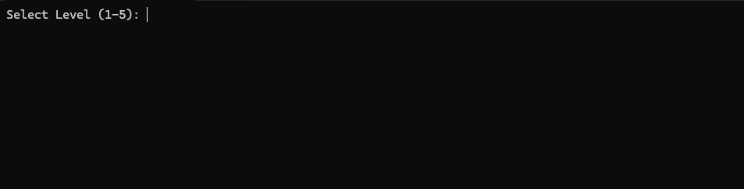
Now we input the level
For level 1:
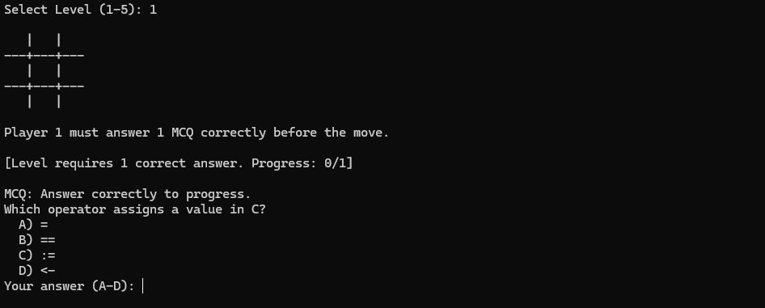
As we can see in the above image the level is selected where we need to answer 1 question to play our turn
For level 5:
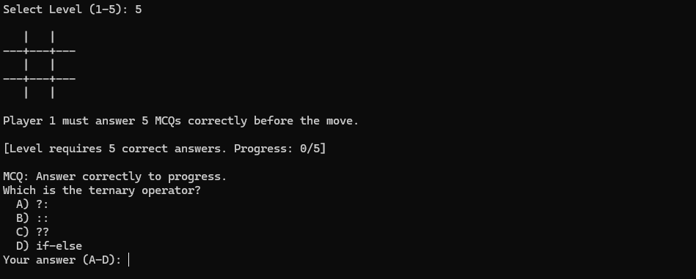
As we can see in the above image the level is selected where we need to now answer 5 question to play our turn.

Player precedence
For the we test the TIC TAC TOE game where we expect
- Player 1 to have “X”
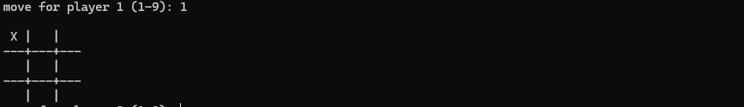
As we can observe when player 1 inputs matrix position the “X” gets printed on the board.
- Player 2 to have “O”
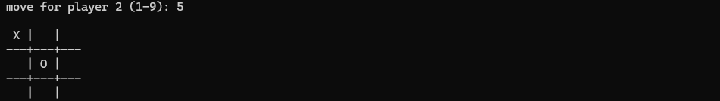
As we can observe when player 2 inputs matrix position the “O” gets printed on the board.

MCQ system
Level 1
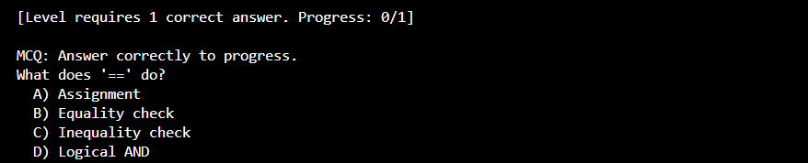
In level 1 we need to answer 1 mcq right so when we answer the mcq correctly
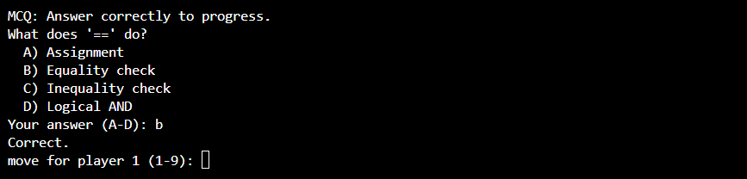
The player gets a chance to play his turn as the program ask the play where he would like to play the matrix position

Level 5
In level 5 we need to answer their 5 questions right to get a chance to play turn
Correct answers
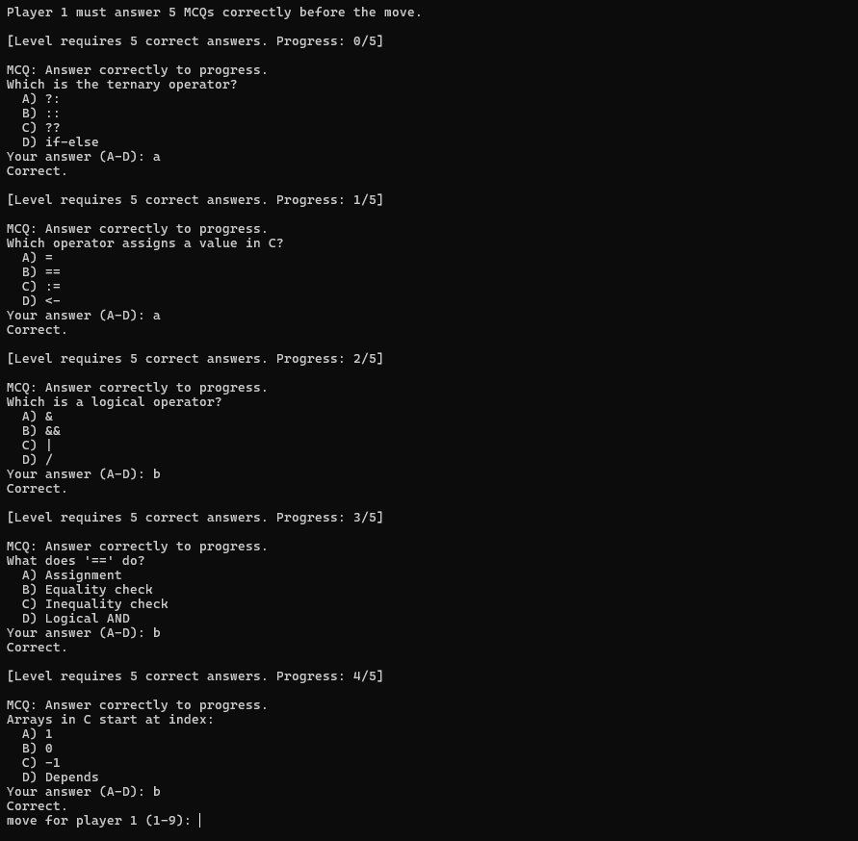
In the above image we can see that in level 5 we can see that after every mcq asked we need to answer one question right we get another question when all the questions answered correctly we get a chance to play our turn on the Tic Tac Toe matrix by inputting the right matrix.

Incorrect answer
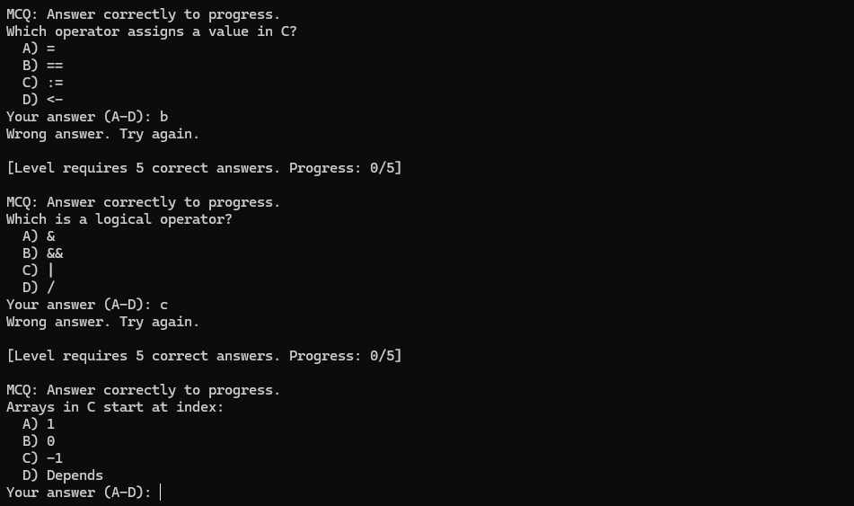
In the above image we can see that when player 1 answers the question wrong player 1`s progress in answering the right question gets rested making him answer the question right again (ie 5 time ) to get be able to play his turn on the Tic Tac Toe matrix.

Matrix display
In this part of the testing, we expect to see how the matrix gets displayed on the board. It shows how the board is printed in the game console. The Tic-Tac-Toe game, the board is represented internally using a one-dimensional array that logically maps to a 3×3 matrix. Each element of the array corresponds to a specific position on the game board. When printing the board, these array elements are arranged in a matrix-like format using formatted output statements.
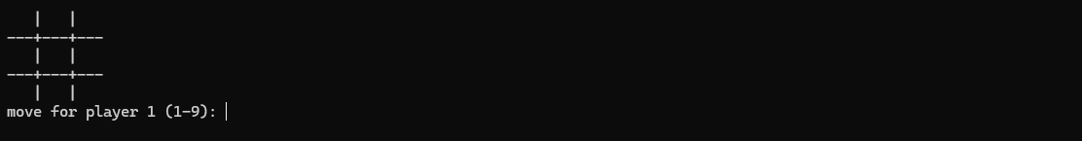
The printing process displays three elements per row, separated by vertical bars (|) to visually distinguish columns. Horizontal separator lines are printed between rows to clearly represent the grid structure. This formatting helps players easily identify positions and understand the current state of the game.
As the game progresses, the array values are updated with player symbols (X or O). Each time the board is printed, the updated values are reflected in their respective matrix positions, ensuring that players see an accurate and real-time representation of the game board. This approach provides a clear, readable, and user-friendly visualization of the Tic-Tac-Toe matrix in a console environment.

Player input
In this part of the testing we check whether the input is “X” and “O” and whether the input matches with the player positioning we also check how the game handle positioning of the player input.
There are 3 types of inputs that shall be checked which are:
Level input
Multiple Choice Question option input
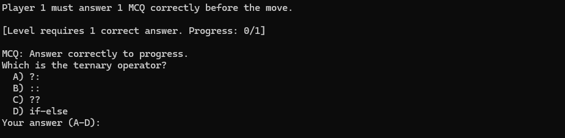
Matrix position input
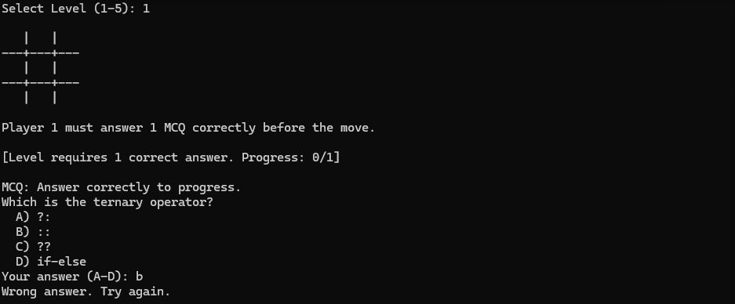

Correct position
Level Input
We test the Level input and what does it respond when the level is being entered. As we can see the when we enter level as 1 we get the level 1 conditions in the game where we need to answer 1 question right to play our turn in the game.
Multiple Choice Question input
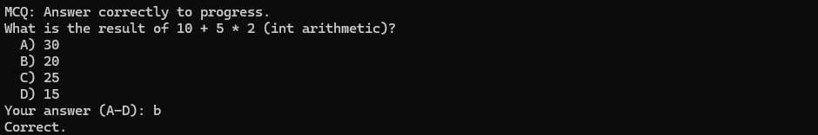
We test the MCQ input and what does it respond when the input is being entered correctly. As we can see the when we entered the right answer the game identifies the answers as correct
Matrix position input
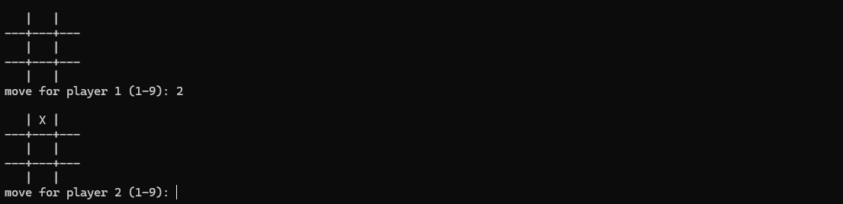
We test how the board prints after we input the move of player and how it updates as we can see when we input the player position the board reprints and puts the player position according to the corresponding matrix index.
Invalid position and error handling
Level Input
There is no wrong incorrect player handling in the program if we input the number which dose not fit in the range of the levels. The program rounds it of to the higher or the lower level respectively.
When level is 0 or less than 0
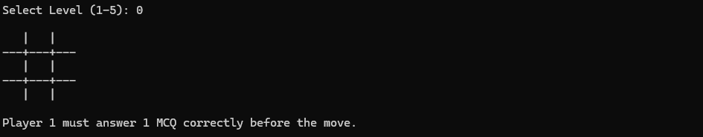
When level is greater than 5
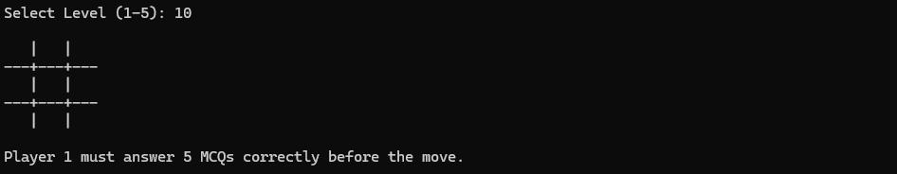
Multiple Choice Question input
The MCQ of the Game take in the player input with the form of characters that are “A,a” ”B,b” “C,c” and “D,d” exclusively hence when we input and characters or numbers other than the respective characters the input is considered invalid and reprints another random question.
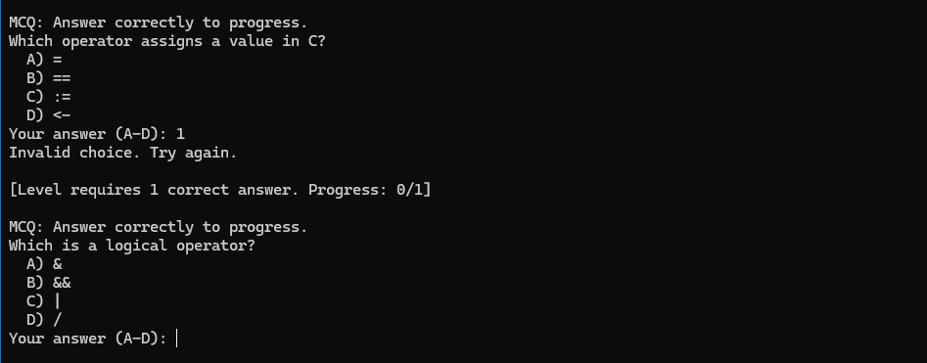
Same happens when any symbol is entered
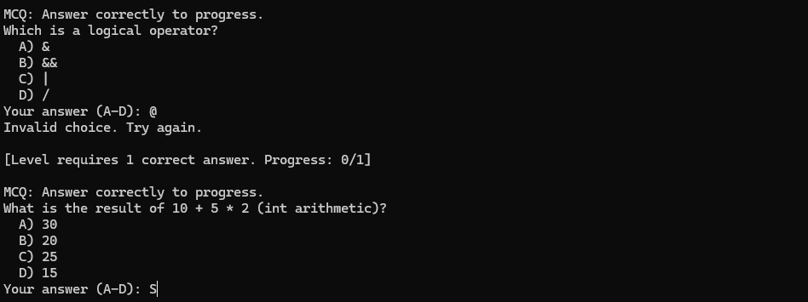
Matrix position input
In invalid matrix positing when the invalid input entered in the game the program makes the players to answer a MCQ again while mentioning the range from which we ae expected to receive the input
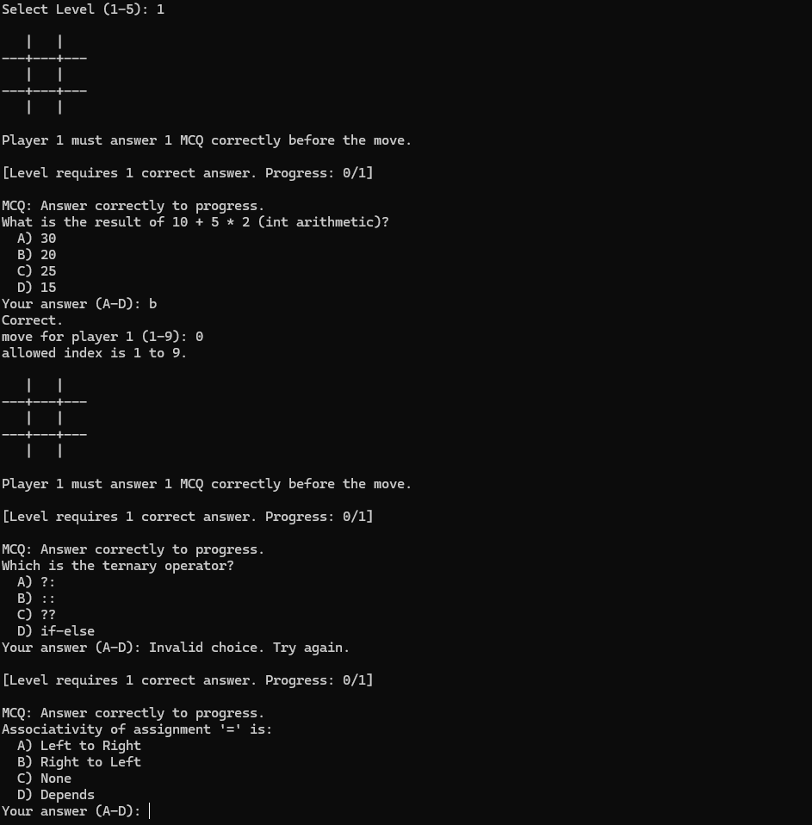

Matrix update after input
In this part of the testing, we test how the game updates after we give the input in the game and how it reprints the board.
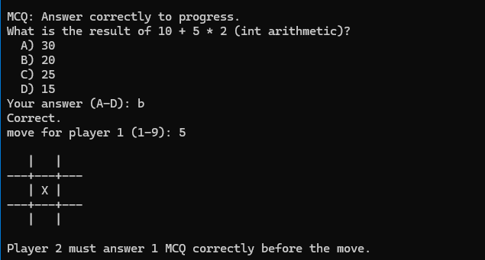
As illustrated in the above image, once the player answers the MCQ, the system validates the response to determine its correctness. If the answer is correct, the player is granted permission to proceed with the game by entering a position value. The entered position corresponds to a specific cell in the tic-tac-toe matrix. Upon successful input, the game updates and prints the board, displaying the player’s symbol at the selected position within the matrix. This mechanism ensures that gameplay progression is conditional on correct answers, thereby integrating learning assessment with interactive game mechanics..

Winning condition
In this phase of testing, the correctness and reliability of the Tic Tac Toe game’s winning logic are verified. The test cases ensure that the game accurately detects all valid winning combinations, including horizontal rows, vertical columns, and diagonal patterns. Each player’s moves are evaluated after every turn to confirm that the system correctly identifies a win when three identical symbols (X or O) are aligned. Additionally, the testing confirms that the game promptly declares the winner, prevents further moves after a win, and avoids false positives when no valid winning condition is met.
  - Row
In this winning condition we check the horizontal winning condition ofthe game where we check three row
Row 1
In this condition we check the winning condition of the program of the 1st row where first three elements of the game row matrix are same.
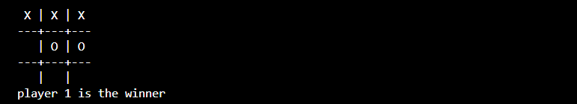
Row 2
In this condition we check the winning condition of the program of the 2nd row where first three elements of the game row matrix are same.
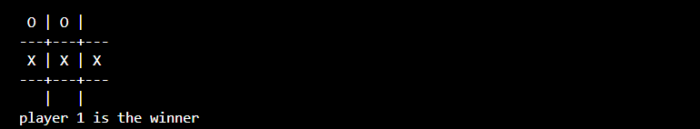
Row 3
In this condition we check the winning condition of the program of the 3rd row where first three elements of the game row matrix are same.
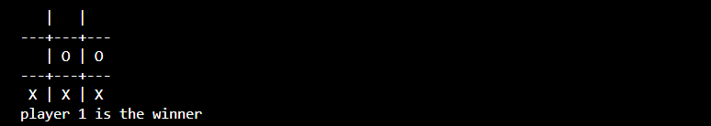
  - Column
In this winning condition we check the vertical winning condition of the game where we check three Column
Column 1
In this condition we check the winning condition of the program of the 1st column where first three elements of the game column matrix are same.
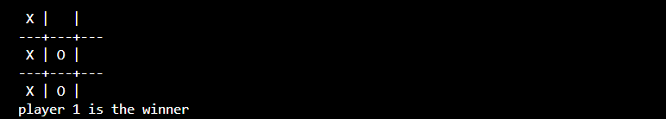
Column 2
In this condition we check the winning condition of the program of the 2nd column where first three elements of the game column matrix are same.
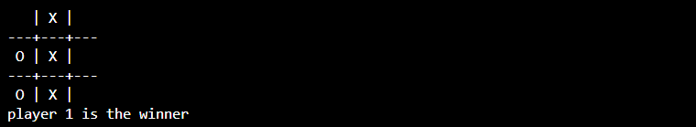
Column 3
In this condition we check the winning condition of the program of the 3rd column where first three elements of the game column matrix are same.
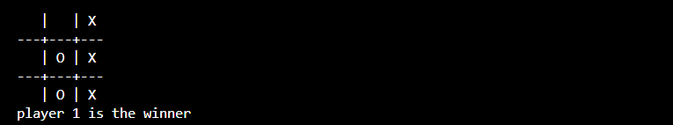

  - Diagonal
In this winning condition we check the Diagonal winning condition of the game where we check three rows and columns for similar elements in the matrix
Left to Right
In this condition we check the winning condition of the program Where the matrix positions (1,1), (2,2) and (3,3) are same. These positions check from right to left.
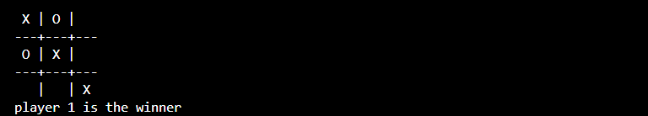
Right to Left
In this condition we check the winning condition of the program Where the matrix positions (1,3), (2,2) and (3,1) are same. These positions check from Left to Right.
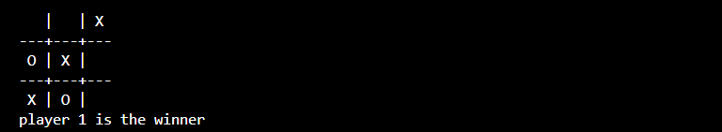
Draw
In this stage of game testing, the system verifies the draw condition of the game. A draw occurs when neither player achieves a winning state by aligning three identical symbols in a horizontal, vertical, or diagonal sequence, even after all board positions have been filled.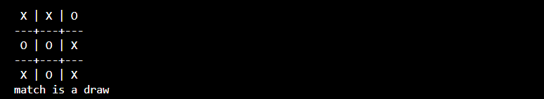
As shown in the above illustration, no row, column, or diagonal contains three matching elements. Since no winning condition is satisfied by either player, the game correctly concludes the match as a draw.

- Conclusion and Learnings-

Conclusion
This project successfully demonstrates the design and implementation of a console-based Tic-Tac-Toe game using the C programming language, enhanced with an MCQ-based learning mechanism. By integrating a traditional two player game with quiz-based level conditions the project goes beyond basic gameplay and introduces an educational dimension that encourages logical thinking and conceptual understanding of C programming fundamentals.
The modular structure of the program divided into level selection MCQ question bank, randomizer, and core game logic ensures clarity maintainability and scalability. Proper input validation, turn management, and winning-condition checks contribute to the robustness and reliability of the application. The use of flowcharts and pseudocode prior to implementation helped in systematically translating problem statements into executable logic.
Overall, the project achieves its stated objectives by creating a low-level, system-independent game that combines entertainment with learning. It highlights how simple algorithms, when thoughtfully structured, can result in an interactive and engaging application suitable for beginners in programming.

Learnings
Through the development of this project, several important technical and conceptual learnings were gained:
- Understanding of C Programming Fundamentals
The project strengthened practical knowledge of core C concepts such as arrays, loops, conditional statements, functions, and header files.
- Modular Programming Approach
Dividing the program into independent modules improved code readability, debugging efficiency, and future extensibility.
- Input Validation and Error Handling
Handling invalid inputs, buffer clearing, and range checking highlighted the importance of writing safe and user-friendly programs in C.
- Game Logic and Control Flow
Implementing turn-based logic, move validation, and win/draw conditions provided hands-on experience in designing real-time decision-making systems.
- Integration of Learning with Gameplay
The MCQ framework illustrated how educational content can be embedded into applications, making learning interactive rather than passive.
- Pre-implementation Planning
Creating flowcharts and pseudocode before coding reinforced the value of planning and logical structuring in software development.
In conclusion, this project not only enhanced programming skills but also improved problem-solving ability and logical thinking, laying a strong foundation for more advanced applications in game development and educational software design.

-GitHub Link-



Link to the repository is hyperlinked to the image
Or
Scan the Qr code


-Reference-
Tic Tac Toe Game in C
Link: https://www.geeksforgeeks.org/c/tic-tac-toe-game-in-c/
Tic Tac Toe in C Programming Tutorial for Beginners | Programming Project
Link: https://youtu.be/4XwAZx9hjGc?si=fB1qVAplfblW3SQS
Quiz Game in C
Link: https://www.geeksforgeeks.org/c/quiz-game-in-c-2/
Multiple choice menu program in C using the switch statement and scanf () function [duplicate]
Link: https://stackoverflow.com/questions/33170752/multiple-choice-menu-program-in-c-using-the-switch-statement-and-scanf-functi
Quiz Game | C Programming Example
Link: https://youtu.be/tG--A0ZMLnA?si=Fh18VE6I1w56XQKi
Let's code a QUIZ GAME with C programming!
Link: https://youtu.be/HDlm1imM7mU?si=c8cJ3zqx9kDcSkR3
C++ create a random number generator
Link: https://youtu.be/bYEdLCWJeHA?si=cxAQQFuB38GzYmfv

Day/Date | Time | Topics covered
15/11/25 | 1 Hours | Synopsis
17/11/25 | 1 Hours | Synopsis
18/11/25 | 2 Hours | Review of Literature
20/11/25 | 1 Hours | Game Synopsis
22/11/25 | 2 Hours | Flowchart
22/11/25 | 0.5 Hours | Review of Literature
23/11/25 | 2 Hours | Flowchart
24/11/25 | 2 Hours | Flowchart
25/11/25 | 0.5 Hours | Review of Literature
25/11/25 | 2 Hours | Flowchart
28/11/25 | 2 Hours | Pseudocode
29/11/25 | 3 Hours | Pseudocode
30/11/25 | 2 Hours | Pseudocode
1/12/25 | 2 Hours | Pseudocode
2/12/25 | 0.5 Hours | Review of Literature
3/12/25 | 2 Hours | Program Modules
4/12/25 | 3 Hours | Program Modules
6/12/25 | 2 Hours | Program Modules
7/12/25 | 1 Hours | Program Modules
8/12/25 | 1 Hours | Program Modules
9/12/25 | 2 Hours | Program Modules
15/12/25 | 1 Hours | Game Testing
19/12/25 | 2 Hours | Game Testing
20/12/25 | 3 Hours | Game Testing
21/12/25 | 2 Hours | Game Testing
22/12/25 | 2 Hours | Game Testing

